Speech Outline
- Tech Monopolies
- Speech: A Fundamental Human Right
- The conflict between freedom of speech and tech monopolies

Presentation Speech
In the year 2020, technology has intertwined its way into our everyday lives. Now, everyone walks around with a smartphone in their pocket. According to Statista.com, in the United States, there is a 99.4% chance that you are likely of having a phone made by either Apple or Google. The next largest competitor, at 0.5% market share of mobile phones, is Microsoft.
[CLICK]
Speaking of Google, when you need to look something up, what’s the best place to begin? That’s right, “Google It.” Based on Net MarketShare, Google receives 83% of all search queries across all platforms, browsers, and devices. But Google isn’t the only tech giant to provides immediate and on-demand information.
[CLICK]
Twitter is known for being the central-local for public discourse. You can find and follow any friend, celebrity, musician, comedian, politician, or anyone, I mean, who doesn’t have a Twitter.

Now you may be asking, what do any of these multi-billion dollar companies have to do with ethics, they’re just a bunch of websites on the internet? Well, I’m glad you asked.

[CLICK]

There are a number of human rights that are enforced by law, [CLICK] innocent until proven guilty, freedom from discrimination, the right to own property, the right to no cruel or unusual punishment.. to name a few. But there is one human right that is paramount to all the rest.
[CLICK]
The great philosopher Socrates lived around 339 BC, over two thousand three hundred years ago. He was known for being sentenced to death for the controversial discussions he held in the town square.
[CLICK]
A human right that no other place on earth besides the United States of America protects by law. The right to freedom of speech. Without this human right, the freedom of speech, none of the other human rights could exist.

[CLICK]

The difference between public discourse today, and the times of Socrates, are that the methods in which discussion is held have changed, they’ve moved to an entirely new platform. Instead of going down to the town square to engage in dialogue with those physically located in the area, now all you have to do is make a post on social media. A platform that is so powerful that your post may get hundreds of thousands or even millions of likes and shares without ever leaving the comfort of your home. A platform that enables more voices than ever seen before in human history to engage dialogue.
According to statista:
- 3.6 billion users on social media networks worldwide in 2020
- Predict that there will be 4.41 billion by 2025

[CLICK]

But today, in America, you are protected to freely speak about any topic, no matter how controversial, without punishable consequences. There are a few exceptions to this law according to Wikipedia supreme court rulings;
- You may not advocate for violence
- You may not make threats that incite bodily harm or death
- Obscenities; child pornography

[CLICK]

The united states supreme court has rules ‘Hate Speech’ a protected speech, this would include racial slurs and another distasteful language

[CLICK]

The united states have another law that protects the freedoms of private companies, the right to freedom of association. The US protects private businesses to refuse services to anyone it chooses for any reason at all. The most prevalent example of this would be the battle between what Twitter believes to be acceptable free speech and what the US government legally protects

[CLICK]

But what if you were not allowed to express your legally protected human right to free speech on these platforms? What if, for exercising the right to freedom of speech, you were denied access altogether, these vast platforms of public information? What if you were not allowed to speak in the most significant areas known today for conversations to be had? Would that be a violation of your human rights? Silencing an individual’s voice in a public forum must be a violation of the right to free speech. Is it ethical for these companies to only allow speech they agree with and to silence the voices of opposition?

Robert Epstien
Tim pool
Three solutions

- Allow all speech
- Enforce legally protect speech
- Require a more selective set of guidelines to reflect a more restrictive morality

A need for ethics in CS

This ethical issue does not have a clear cut solution. The most appropriate solution to this issue varies depending on one’s own morals. One might argue that all speech is protected, and thus no matter the content or context should be allowed. This argument has some immediate criticisms. There is most certainly content, that can be considered speech, which is a violation of the law, which begins us to our next possible solution. To allow dialogue which is protected under the law. For example, speech that incites violence is against the law, child pornography is punishable by governemnt authority, and to is . There are legal repercussions for telling others to inflict harm on another. Although there still remains categories of speech that some view as distasteful, and that should be a violation of the law. For example, racial slurs, hate speech is protected speech under the law. The final solution, the currently enforce terms and conditions on social media, is a set of rules that extends the law to include categories of hate speech and other distasteful language.

Dilemma
- Social media companies are holding a monopoly on areas of public discourse.
- Search engine market share
  - https://netmarketshare.com/search-engine-market-share.aspx?options=%7B%22filter%22%3A%7B%7D%2C%22dateLabel%22%3A%22Trend%22%2C%22attributes%22%3A%22share%22%2C%22group%22%3A%22searchEngine%22%2C%22sort%22%3A%7B%22share%22%3A-1%7D%2C%22id%22%3A%22searchEnginesMobile%22%2C%22dateInterval%22%3A%22Monthly%22%2C%22dateStart%22%3A%222019-08%22%2C%22dateEnd%22%3A%222020-07%22%2C%22plotKeys%22%3A%5B%7B%22searchEngine%22%3A%22Google%22%7D%5D%2C%22segments%22%3A%22-1000%22%7D
- Twitter and other platforms
  - https://chrissniderdesign.com/blog/resources/social-media-statistics/#:~:text=30%2C%202019%3A%20Facebook%20reports%202.45,145%20million%20monetizable%20daily%20users.&text=July%2026%2C%202019%3A%20Twitter%20reports,million%20daily%20monetizable%20active%20users.
- Share of the smartphone in the market
  - https://www.statista.com/statistics/266572/market-share-held-by-smartphone-platforms-in-the-united-states/

If
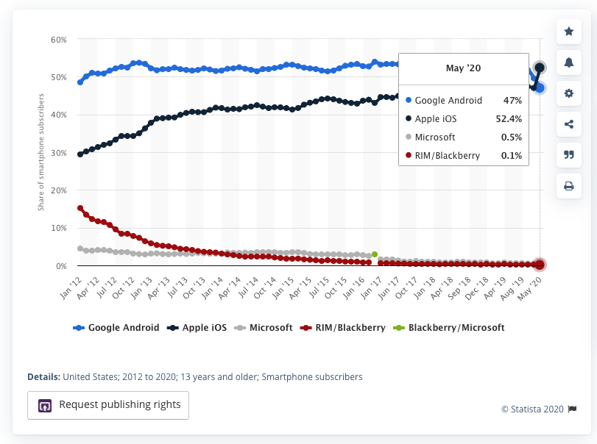

https://www.statista.com/statistics/278414/number-of-worldwide-social-network-users/#:~:text=Social%20media%20usage%20is%20one,almost%204.41%20billion%20in%202025.&text=Social%20network%20penetration%20is%20constantly,2020%20stood%20at%2049%20percent.

https://en.wikipedia.org/wiki/United_States_free_speech_exceptions

https://www.youtube.com/watch?v=DZCBRHOg3PQ

